Sophos Home Commercial Use Edition (For Student/Employee Home Computers) - Download & Install Instructions…

These instructions are only for personally-owned computers only. This offering is not to be used for university-owned computers as these are currently managed by ITS.

Sophos is an anti-virus software, also known as anti-malware, used to prevent, detect, and remove malware.
Windows
To Download and Install Sophos, complete the steps below:
Since NYIT employees are working remotely to avoid contracting and/or spreading COVID-19, additional protection is available for their home computers. These instructions will show you how to download the Sophos antivirus software on your remote device.

1. Go to the Sophos Home Commercial Use Edition login page.
2. Enter your NYIT email, then click Submit.
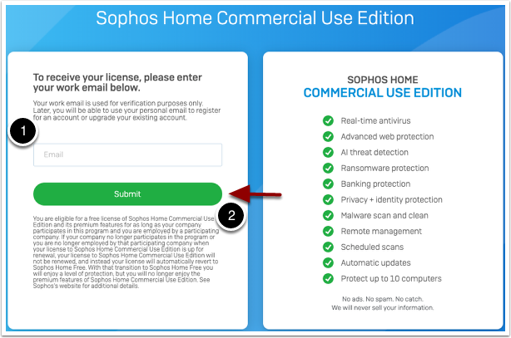
3. A confirmation link will be sent to your email. Check your inbox and click the link provided, then follow the steps to finish the confirmation.
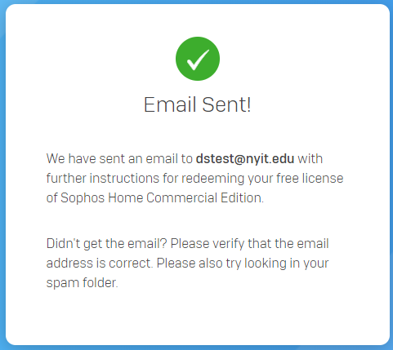

4. Click Create Account button

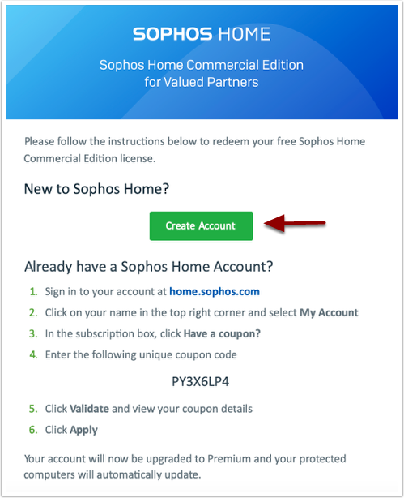

5. Fill in the boxes to register. Then click Create Account.
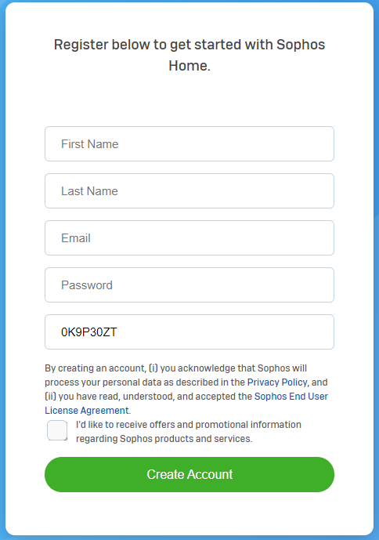
If the coupon code does not autofill, use the code sent in the confirmation email.
6. You will receive a confirmation email. Click Confirm email, and sign in with the username and password you just created in step 4.
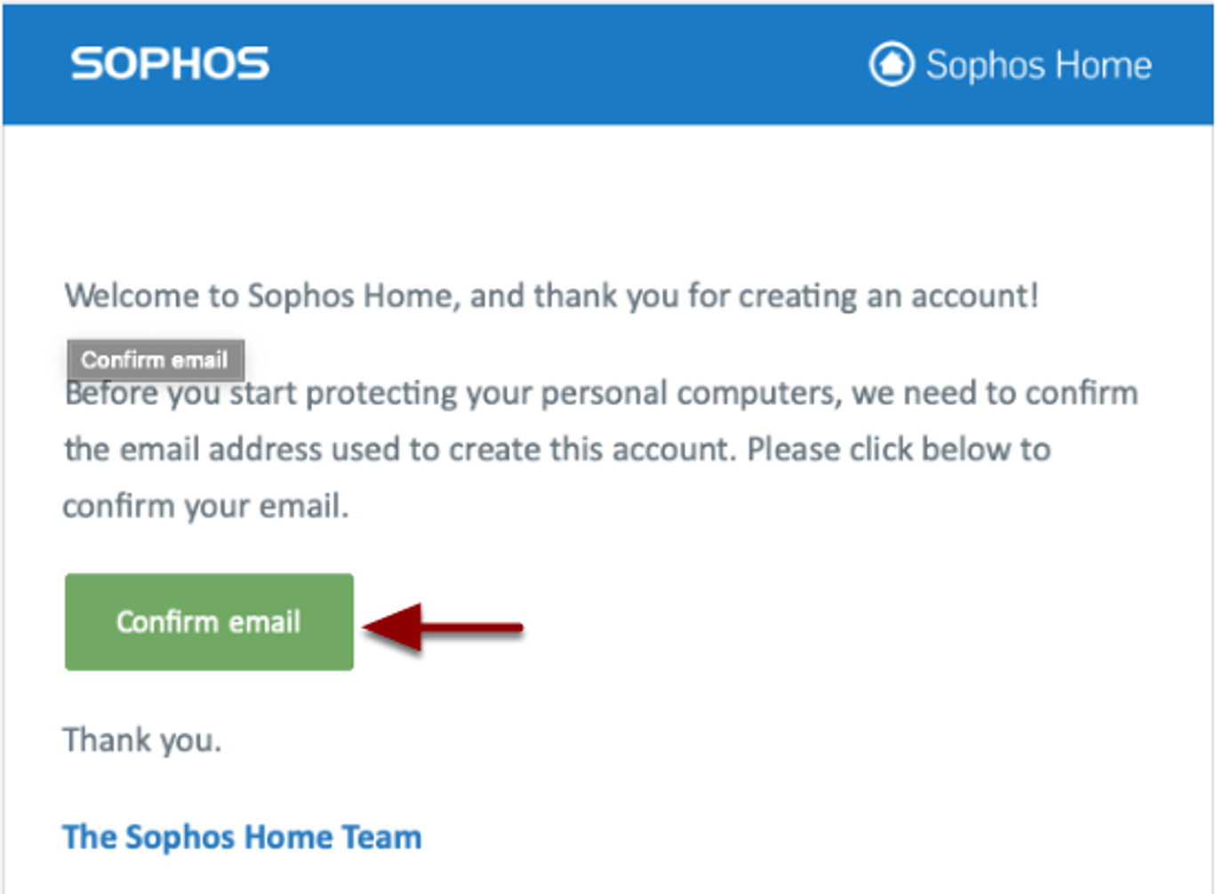

7. Click Download.
8. Run the SophosInstall file to install the software and follow the steps in the installation wizard to complete Installation process.
It should typically take about 6 minutes to install and will require a restart.

