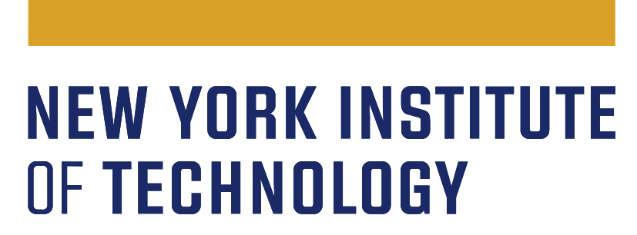
Continuous Program Improvement (CPI)
Student Support Units - Student Success/Achievement
Three Year Assessment Plan - 2022-2025

Unit name
Expected date of submission | 06/30/2022
Unit head/director

The Middle States Commission on Higher Education (MSCHE) Standard V, Educational Effectiveness Assessment, states: “Assessment of student learning and achievement demonstrates that the institution’s students have accomplished educational goals consistent with their program of study, degree level, the institution’s mission, and appropriate expectations for institutions of higher education.”
To ensure that New York Tech’s CPI process meets this standard, each student support unit is requested to create a three-year assessment/evaluation plan to improve student success/achievement. The plan should cover the following academic years: 2022-2023, 2023-2024, and 2024-2025.

Each student support assessment plan should include the following:

- The unit’s mission & goals (aligned with institutional mission and strategic action plan goals).

Mission:
Goal(s):

- The major functions of the unit.
- A systematic process to obtain relevant data to evaluate the performance of each function and to determine program effectiveness in achieving its mission and goals (see example on the following pages). This process should:
- Be written, ongoing, and used to determine effectiveness of the program(s) in your unit
- Be comprehensive (i.e., includes assessment of all major function areas)
- Identify what quantitative and/or qualitative data are collected to assess the effectiveness of the program functions, including baselines and improvement goals
- Include timelines and personal responsibilities for implementation, data collection, review of expected and actual outcomes, and determination of the program’s effectiveness in achieving its mission and goals
- Be periodically reviewed and revised as appropriate
- Be a cyclical, PDSA process (Plan, Do, Study, Act)

- A description of how the plan and results will be conveyed to your unit. (It is strongly recommended that all stakeholders, including students, are involved in the assessment process.)

Plan Example - Advising and Enrichment Center

Unit function | KPIs (measures) | Baseline | Goals (Improvement) | Personal Responsibilities to implement and re-evaluate the outcomes | Timeline
1. Advising- First Year | - # and % of New Admitted UG students who met with AEC and enrolled for Fall  - # and retention rate of New Enrolled students who met with AEC  -# and % who are on track for 4 yr graduation at the end of their first year (met with AEC vs not)  - Satisfaction of students who meet with AEC | - 825 new admitted UG students meet with AEC each year, on avg; 92% enroll, on avg  Next Term Retention, met with AEC  -647 students return in the next term, on avg  -86% enroll in the next term, on avg  Next Year Retention, met with AEC  -541 students return in the next year (or graduate), on avg  -72% enroll in the next year, on avg  - based on two years data | -Meet or exceed baseline rate for those who meet with AEC |  | 2022-2025
2. Advising- Continuing | -# and % of continuing UG students who met with AEC and enrolled  -# and % of continuing students who meet with AEC and enroll based on NYE campaign (email, phone, etc.)  -Satisfaction of students who meet with AEC | - AEC meets with over 1900 non-freshmen students/year, on avg  - 96% of these students enroll in the next term, on avg  - 91% of students who meet with AEC based on a "Not Yet Enrolled" Campaign enroll, on avg  -based on two years data | -Meet or exceed baseline rate for those who meet with AEC |  | 2022-2025
3. Early Alerts | -# of submissions received (total and by unique faculty)  -# of students AEC connected with successfully  -# and % of non-failing grades (met with AEC vs not) | - AEC receives an avg of 393 alert submissions/year  - avg 85 unique faculty submitters/year  - AEC connects with roughly half of the students for whom early alerts are submitted (190, 49%)  - The other half (203, 51%) are non-responsive or have "other" case closure reasons | -Decrease the DFW rate for those who meet with AEC  -Increase faculty/staff usage by way of unique submissions |  | 2022-2025
4. Academic Probation | -# and % of students on academic probation who met with AEC and return to good academic standing (GAS) at the end of the semester  -# and retention rate of students on academic probation who met with AEC | Data in Progress | -#% of students to return to GAS (increase based on baseline data)  -#% of students to increase their cGPA (increase based on baseline data) |  | 2022-2025
5.Peer Tutoring | -% of DWF for tutees (for the course(s) in which they were tutored)  -# of tutoring appointments (total)  -# of courses tutored (distinct count)  -# of tutees (distinct count)  -Satisfaction of tutees | DWF Rates: 15.2%  -Based on a 4 year average | Goal for DWF Rates: Below 13% |  | 2022-2025
6.Supplemental Instruction | -% of DWF grades for SI session attendees  -% of attendance(average)  -Average course grade of SI session attendees vs those who didn't attend  -Satisfaction of SI session attendees | -DWF Rates: 11.29%  -Average course grade of SI session attendees = B  -Based on a 2 year average | -DWF Rates:Below 10%  -Average course grade of SI session attendees = B or Better  -Improve SI data collection  -Improve attendance among students at risk of performing poorly. |  | 2022-2025
7.Peer Mentoring | -# of students who interact with PSGs  -Persistence/Retention of those who interacted vs those who did not  -Change in Sense of Belonging for those who interact vs those who did not  -Satisfaction with the GUIDE program | N/A - New Program | -Increased measure of Sense of Belonging assessed via the 25-item, 5-point pre/post survey (targeted level of increase to be determined once the pre-survey is launched) |  | 2022-2025
8.First Year Success Course | -# of students who completed at least 1 module  -# of modules (average) completed per student  -# of students who felt the course improved their knowledge and help them navigate through their first year | N/A - New Initiative | -X Percentage of first year students who completed Y or more modules (X & Y to be determined by after ongoing work on the course is finalized) |  | 2022-2025

